
SHED NO 27, SHUBHAM INDUSTRIAL ESTATE, NR. TORENT POWER SUB STATION, KATHWADA GIDC, AHMEDABAD – 382430
GST NO: - 24ARDPD2565K1ZX

info@torqpackagingsolution.com
www.torqpackagingsolution.com

Date: - 17/03/23

To,
MAA KALYANEE LUBRICANTS
BORGANG, BISWANATH
MOBILE: - 887667455
GST: - 18CFMPD2898L1ZQ
STATE NAME : ASSAM, CODE :18

SUB: - SEMI AUTOMATIC FILLING MACHINE

Dear Sir,
Many thanks for your valuable inquiry of above subject. TORQ PACKAGING Solutions Is engage in making preliminary Bottle Filling machines like bottle filling , capping , labeling, etc… in Ahmedabad, We are having dedicated team for manufacturing, customized machine development, Sales, servicing and back office.

Thanks & Regards
Ronak Dave
80000 32128

Automatic 2 head servo Filling Machine 200 ml to 5L
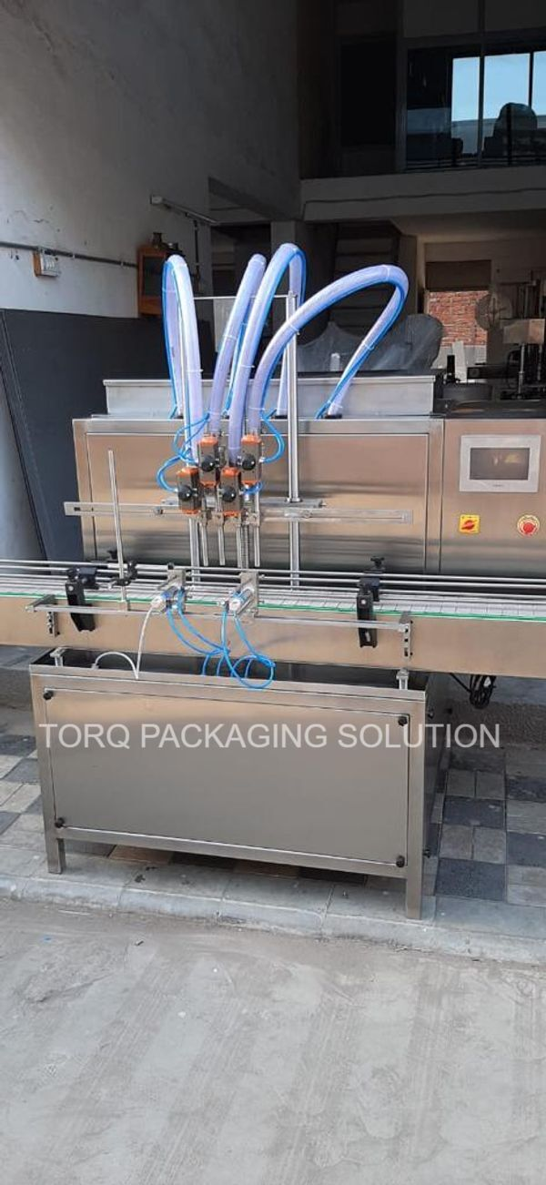

Description
The Electronic PLC Based Filling Machine is compact and highly efficient machine with elegant look. This multi functional multi featured machine meets the GMP requirements of filling for glass, plastic or Aluminum bottles. The flow of liquid is measured and converted in to electronic signals being controlled by micro computer base circuitry. Minimum adjustment required to set different capacities from 500ml to 5 Ltr with varying containers. The entire range can be set on the same machine without any change parts with help of flow meter pulses.
Operation
Nozzle goes upwards slowly from the bottom level of bottle towards neck during filling to minimize foaming adjustable nozzle is reciprocating according to filling dose
The filling synchronized with conveyor drive and conveyor drive controlled by Ac frequency drive. The speed can be set in terms of bottles per minute. The conveyor drive consists of a hallow shaft, geared motor controlled by Ac frequency drive. A knob can set the speed of conveyor.
Technical Specifications
Filling Range |  | 200 ml to 5 Litr
Output/Min* |  | 24 to 26 Bottle per Min. (Based on 500ml)  8 to 10 bottle per min. (Based on 5 litr)
Direction of Movement |  | Left to Right
Number Of Head |  | 2 Nos.
Electric Supply |  | 230 V / 50HZ
Conveyor Motor |  | 0.5 HP / 415 V / 50 HZ
Conveyor AC Drive |  | 0.5 HP / Delta make
Flow Control Valve |  | Yes
Servo |  | Delta Make
PLC |  | Delta Make
HMI |  | Delta color display
Push Buttons |  | Telemechanique make
Pneumatic Solenoid Valves |  | Janatics make
Pneumatic Cylinders |  | Janatics make
FRL |  | Janatics make
Dimensions |  | 1800 L x 1250W x 2600H
Net Weight |  | 900 Kgs. Approx.
Input Specification
Filling Speed:
The estimated filling speed of the machine is as follows:
The above filling speeds are applicable for nozzles of 19 mm Ø and container mouths of minimum 39 mm Ø. Speed shall stand reduced for smaller mouth containers, product viscosity & foaming characteristics and temperature of product the time of filling.
The container should have 20% of empty volume space after filling the desired volume to get the estimated speed.
Drip Free: Absolutely “drip free” deliveries through specially designed nozzles. Ensures rapid recycling of sequence.
Accurate: Repeat accuracy of ± 0.2 to 0.5 % for the specified filling range can be achieved.
Safety Device: Non-contact electronic sensors ensure “no bottle no fill” status to avoid spillage in absence of container.
Material of Construction: All contact parts are made out of from SS 316 or Food/pharma grade as per GMP norms, and non contact visible parts made out of SS 316 and/or mild steel and cladding of SS 304.
* Depends on Container size, fill size, Neck diameter of container, and nature of liquid etc.
Salient Features
- No Bottle No Filling System.
- All Contact Parts made of S.S.316
- 2 Filling Stations, space saving design.
- Easy to clean
- Pneumatically controlled nozzles, with ‘No Container No Fill’ arrangement.
- Drip free nozzle arrangement.
- Reciprocating filling nozzle with self-centering device.
- Pneumatically operated bottle stopper.
Utility Requirement
Electrical supply | 1 Phase + Neutral + Earthing
Electrical load | 1.2 KW
Air Pressure | 6 bar pressure 10 CFM

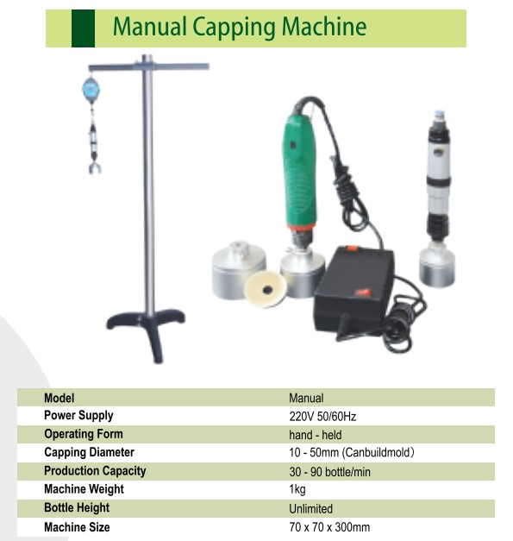

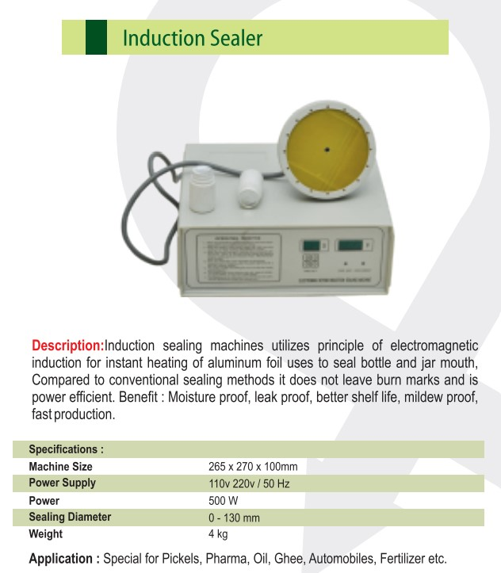

Price Breakup
S.N. | PARTICULERS | CAPACITY | QTY | AMOUNT RS.
1 | AUTOMATIC 2 HEAD SERVO BASE FILLING MACHINE | 200ML TO 5 LTR | 1 | 3,50,000/-
2 | HANDY CAPPING MACHINE | 10 TO 50 MM | 1 | 15,000/-
3 | HANDY INDUCTION CAP SEALING MACHINE | 10 TO 130 MM | 1 | 11,000/-
 | BANK DETAIL:  Account name: - TORQ PACKAGING SOLUTION  Account number: - 8000032128  Bank name: - KOTAK MAHINDRA BANK LTD  Branch: - KATHWADA  IFSC: - KKBK0002606  COMPANY GSTIN : 24AARDPD2565K1ZX | TOTAL |  | 3,76,000/-
 |  | CGST @ 9%
 |  | SGST @ 9%
 |  | IGST @ 18% |  | 67,680/-
TOTAL AMOUNT |  |  |  | 4,43,680/-
TERMS & CONDITIONS |  | For, TORQ Packaging solution
- 60 % Advance on Signing up of Contract
- 40% On Completion of Machinery Manufacturing Before Dispatch / During Inspection of machinery
- Order Once Placed Cannot be Cancelled
- No Refund will be entertained

- TERMS & CONDITION

Commercial terms:
  - The above price does not include the cost of Packing and forwarding, Erection and Commissioning and training of your Operation & Maintenance staff.
  - Insurance extra where ever applicable
  - GST as applicable
  - Subjected to Ahmadabad Jurisdiction Only

Installation & Commissioning
  - At An Extra Cost (To & Fro Loading And Boarding Charge Will Be Extra)

After Sales Services
  - Three Service Free (To & Fro Loading And Boarding Charge Will Be Extra )

  - After Free Service Including Installation 2500/- Rs Charge

Validity
- This Quote is valid for a period of 30 Days.

WARRANTEE
- Warrantee is only applicable against any manufacturing defect.
- The warrantee is only valid for 6 months from the date of supply.
- Client must use the machine/plant/system supplied by us as per the design criteria.
- It shall stand void if the machine is not maintained as instructed.
- Client shall maintain daily operational data sheet
- The use of system beyond the capacity considered during design may affect the performance of the machine and this degradation does not give rise of any obligations on the part of the maker.

